Jonathan Wolanyk

Professor Roberts

CS-360: Mobile Architecture and Programming

March 19, 2023

**Project One - Option 1 (Inventory App) Project Proposal**

**The Goals of the Project:**

The proposed project consists of an inventory application allowing users to monitor their current inventory and adjust the application’s records to maintain an updated inventory log. The application, once finished, will have the capability to both store and retrieve login information as well as keep track of an inventory of items. To access their personal data, the user will be required to input their username and password on the initial login screen, which will feature two editable text boxes: one for the username and one for the password. The login screen will also include a submission button for the user to press once they have entered their login credentials, which will be checked against the database. Upon successfully logging in, the user will be directed to a screen displaying a grid of all items in their inventory. On this inventory screen, the user can add or remove items from their inventory through a set of corresponding buttons next to each row. The application will also alert the user when an item in their inventory has reached a quantity of 0 units left.

**The Users of the Application and the Assumptions Being Made Regarding their Needs and Preferences**:

There are a variety of users that could benefit from this application. For instance, small business owners, chefs, and managers could all benefit from the application. Small business owners need to monitor their inventory to track which products are in stock, which products are selling well, and what products should be increased/decreased in the ongoing order logs to accommodate demand. Warehouse managers will use the application to ensure their inventory can support the needs of their consumers at any given time. Chefs may want to track their kitchen supplies to be prepared for meal services each day.

The proposed application will satisfy users' needs by making managing their inventories quite simple. Instead of attempting to track their inventories by hand or sight, the proposed application will allow users to maintain their inventory numbers directly through the application’s grid that displays their current inventory. Since the users of this application are often trying to be efficient with their time, the ability to interact with a single page to manage their inventory will provide a competitive advantage compared to similar apps that do not offer such a feature.

**Features Necessary to Produce a User-Centered UI for the App**:

Figure 1: Login Page 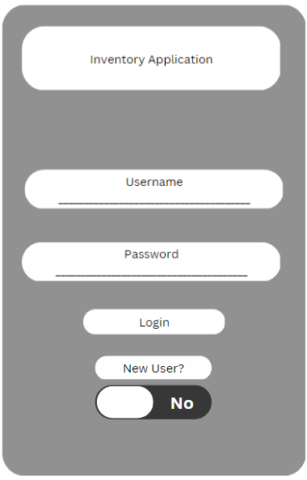

Since this application is designed to save inventory managers’ time, the proposed application will consist of three screens in total; one to log in, another to view and manage the inventory, and a third screen to add news items. The login page will allow a user to enter their username and password. If the user has not signed up before, they can toggle the bar at the bottom of the screen to the “Yes” side, which will take the entered username and password and create a new account with the input. Once logged in, the user will be taken to the inventory screen to access their current inventory.

Figure 2: Inventory Page

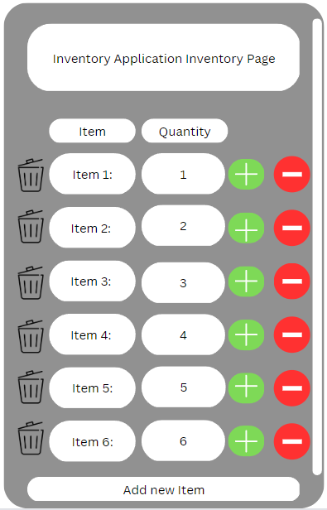

The inventory page will allow users to remove items from the inventory list and adjust the number of items in their inventory. To the left of each entry, a trash can symbol is placed to delete the item from the list. To the right of each entry, there will be a green plus sign and a red minus sign to indicate that each button will increment or decrement the quantity of the item, respectively. At the bottom of the inventory page, the “Add new item” button will take the user to a page that will work to add new items to the inventory list.

Figure 3. Add Item Page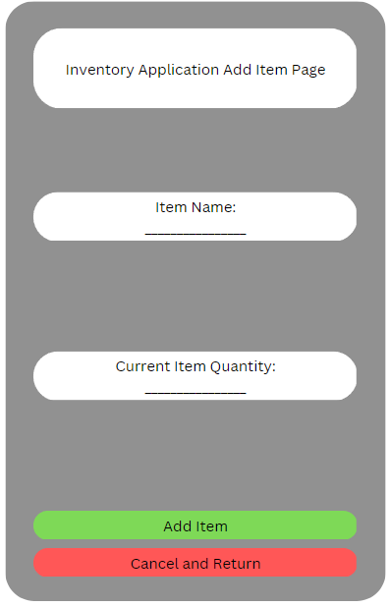

The add item page is quite simple. The page has two text fields for a user to enter the name of the new item and the current quantity. Once entered, the user can select the “Add Item” button to be redirected to the inventory page. If the user would like to return to the inventory page without adding the item, he or she could select the “Cancel and Return” button to do so.

**How the Functional App Requirements Will Be Represented in the Code and Connected to the UI:**

Two main databases will send and receive data in order to make this application function as outlined in the project requirements. The first database will house user login information. To access the application’s inventory page, a user will need a username and password. The username will be associated with the second database, which houses the inventory data for each user.

On the login page, users will enter their usernames and passwords into the editable text fields before selecting the login button. Once the login button is pressed, a call will be made to the user login database to determine whether the combination exists.

Once the user is located based on login information, a call will be made to the inventory database to find the inventory list associated with the user login data. Once located, the inventory list information will be presented on the user’s device. Interacting with the addition or subtraction button next to each item will modify values in the inventory database. Interacting with the trash can button to the left of each item will remove the item from a user’s database.

If a user selects the “Add New Item” button on the inventory page, the application will take the user to the add item page. On this page, a user can modify the editable text fields for the item name and quantity. Once the user selects the “Add Item” button, the inventory database for that user will be updated with the new item description and quantity.

Through the elements and pages listed above, each of the functionality requirements of the inventory application project will be met; users will be able to log in to access their inventory, monitor and adjust quantities in the inventory, and be able to add and remove items from their inventory.